create database task;

use task;

**Task 2**

**CREATE TABLE suppliers** (supplier_ID INT(100) PRIMARY KEY,supplier_name VARCHAR(50) NOT NULL);

insert into suppliers values('1','Flipcart'),('2','amazon'),('3','Dmart'),('4','blinkit'),('5','Ajio'),('6','meeshow'),('7','BigBasket'),('8','Zepto');

select * from suppliers;

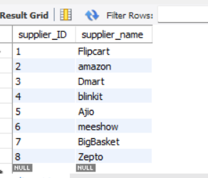

**CREATE TABLE categories** (category_ID INT(100) PRIMARY KEY,category_name varchar(50) NOT NULL);

insert into categories values('11','Electronics'),('22','Clothing'),('33','Kitchen Essentials'),('44','Food'),('55','cosmetics'),('66','jewelry'),('77','Fruits and Vegetables'),('88','groceries');

select * from categories;

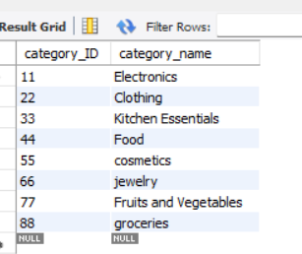

**CREATE TABLE Products (**

Product_ID INT(100) PRIMARY KEY,

Product_Name VARCHAR(100) NOT NULL,

Supplier_ID INT(100),

Category_ID INT(100),

QuantityPerUnit int(100),

UnitPrice INT(100),

UnitsInStock INT(100),

UnitsOnOrder INT(100),

ReorderLevel INT(100),

Discontinued BOOLEAN NOT NULL DEFAULT 0,

foreign key (Supplier_id) references suppliers(Supplier_ID),

foreign key (category_ID) references categories(category_ID));

select * from products;

INSERT INTO products VALUES

('111', 'Earbuds', '1', '11', '1', '10', '20', '40', '1', 0),

('222', 'Kurthi', '2', '22', '2', '20', '30', '50', '3', 1),

('333', 'Non-stick pan', '3', '33', '3', '30', '40', '60', '4', 0),

('444', 'Biriyani', '4', '44', '4', '40', '50', '55', '1', 0),

('555', 'Lipstick', '5', '55', '5', '50', '52', '35', '2', 1),

('666', 'ear rings', '6', '66', '6', '60', '39', '16', '5', 1),

('777', 'Tamatos', '7', '77', '7', '70', '12', '22', '1', 0),

('670', 'burger', '8', '88', '10', '33', '11', '63', '12', 1),

('121', 'dosa', '8', '88', '1', '15', '4', '17', '9', 1),

('453', 'fastfood', '8', '88', '18', '11', '2', '7', '6', 0),

('879', 'bangles', '6', '66', '9', '30', '59', '10', '7', 1),

('675', 'mandi', '8', '88', '2', '8', '94', '37', '6', 0);

select * from products;

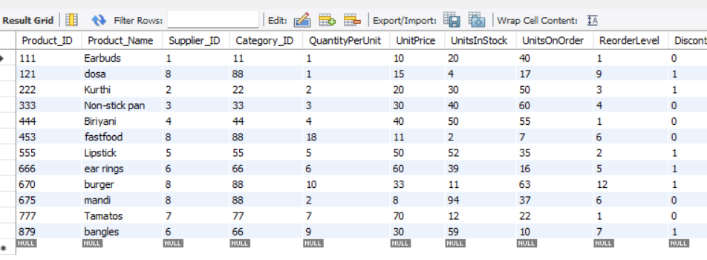

//Write a MySQL query to get Product list (id, name, unit price) where products cost between $15 and 25 rupees.

SELECT product_id, product_name, unitprice FROM products WHERE unitprice BETWEEN 15 AND 25;

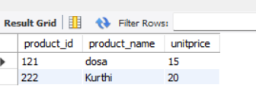

//Write a MySQL query to get Product list (name, unit price) of above average price.

SELECT product_name, unitprice FROM products WHERE unitprice > (SELECT AVG(unitprice) FROM products);

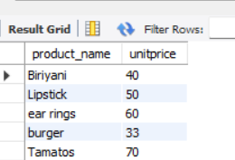

//Write a MySQL query to get Product list (name, unit price) of ten most expensive products.

SELECT product_name, unitprice FROM products ORDER BY unitprice DESC LIMIT 10;

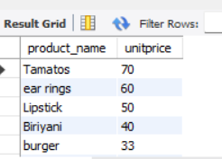

/Write a MySQL query to count current and discontinued products.

SELECT Discontinued, COUNT(*) AS product_count FROM products GROUP BY Discontinued;

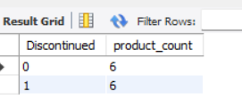

//Write a MySQL query to get Product list (name, units on order , units in stock) of stock is less than the quantity on order.

SELECT product_name, UnitsOnOrder, UnitsInStock FROM products WHERE UnitsInStock < UnitsOnOrder;

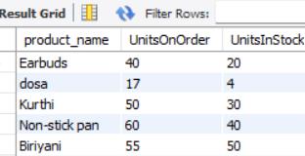

**Task 1;**

// Write a mysql query to get Product name and quantity/unit.

SELECT product_name, quantityperunit FROM products;

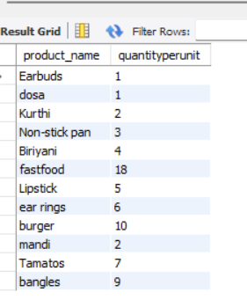

//Write a MySQL query to get current Product list (Product ID and name).

SELECT product_id, product_name FROM products order by product_id;

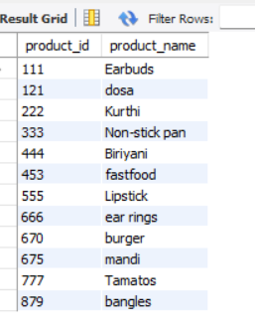

//Write a MySQL query to get discontinued Product list (Product ID and name).

SELECT product_id, product_name FROM products WHERE discontinued = 'discontinued';

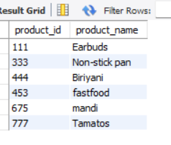

//Write a MySQL query to get most expense and least expensive Product list (name and unit price).

select product_name,unitprice from products where unitprice=(select max(unitprice) from products)or unitprice=(select min(unitprice) from products);

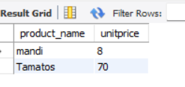

//Write a MySQL query to get Product list (id, name, unit price) where current products cost less than 20 rupees.

SELECT product_id, product_name, unitprice FROM products WHERE Discontinued = 'Discontinued' AND unitprice < 20;

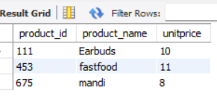

drop table products;

drop table suppliers;

drop table categories;